Plagiarism Detection in Large
Sets of Press Agency News Articles

Wolfgang Kienreich, Michael Granitzer, Vedran Sabol, Werner Klieber

Know-Center, Competence Center for Knowledge-Based Applications and Systems
{wkien|mgrani|vsabol|wklieber}@know-center.at

Abstract

The advent of electronic media enabling rapid publishing and instant access to news articles has vastly increased the working pace of the media industry. Press agencies can no longer afford to neglect plagiarisms formerly perceived as irrelevant because such acts instantly void the commercial value of original and potentially exclusive news articles. From a different point of view, individuals and organizations of public interest require instant evaluation of impact of actions taken and diffusion of statements made in the media. This publication presents a methodology and a prototypical system for analyzing plagiarisms and, in general, diffusion of textual content in newspaper articles and reports on preliminary application results obtained in the context of Austria’s press agency APA.

1. Introduction

Plagiarism is generally defined as “(…) the use of another's ideas, information, language, or writing, when done without proper acknowledgment of the original source (…)” [1]. This topic has recently attracted attention in the educational area, where worries about students copying assignments and solutions available on the worldwide web have resulted in heated discussions and the proposal of numerous methodologies and tools [2][3]. In the context of press agency news, plagiarism takes on a different, more ambiguous meaning.

The archives of large national and international news agencies typically contain millions of articles, with thousands of new entries being added every day. Agency news articles are often based on statements made by political organizations, individuals of public interest or companies, who actively seek publicity by preparing press releases or organizing press conferences on topics of interest. Press agencies compose original articles from this information and distribute them to paying subscribers belonging to two major categories: Media producers, like print and electronic media, and media consumers, including parties seeking publicity as mentioned above.

In the media producer domain, agency news contribute substantially to the text corpus published. Consequentially, plagiarism is rather loosely monitored: Extensive and repeated reuse of whole articles may lead to severe consequences [4], but copying of text snippets from agency news is common practice and has not been considered problematic in the past. However, with the advent of the worldwide web, which enables instant access to, and rapid publishing of, information, press agencies can no longer afford to neglect such practice. Consider a subscriber publishing an article which contains substantial portions of the original agency news article on a frequently visited webpage: The originality and potential exclusive nature of the article in question is instantly voided, and all other subscribers would rightly question the value of an article which, after all, is already available for free. As a consequence, plagiarism detection is becoming increasingly important for news agencies as well as for newspapers in general.

In the domain of organizations, individuals and companies seeking publicity, plagiarism is perceived positive. For a press officer, the optimum result of a press release is that it’s exact text, or at least it’s basic meaning, is copied and distributed across as many media as possible. For a company placing a new product or brand, it is important that the associated terms and slogans are mentioned in the media as often as possible. Consequentially, there is increasing interest in media resonance analysis and media diffusion analysis, inspections which measure how various media reflect the deliberate introduction of new content.
In this publication we present a system which supports semiautomatic identification of plagiarisms in newspaper articles. In a project carried out in close cooperation with the Austrian Press Agency APA [5] and it’s subsidiary responsible for media analysis, APA MediaWatch [6], a methodology has been devised, and a prototype has been implemented, supporting the identification of plagiarisms in large article repositories. Section 2 of this publication briefly outlines the project environment the prototype was developed in. Section 3 points out details of the methodology used, while section 4 describes the prototype which was designed to implement the methodology. Section 5 names some preliminary results gathered when applying the system to a practical environment. Further sections point towards future work and conclude this publication.

2. Environment

The Austrian Press Agency APA is Austria's national news agency and one of the country's leading information providers. APA Defacto, APA’s subsidiary specializing in knowledge technologies and services, provides customers with several millions of documents available for enquiry through a visual query interface [7]. APA MediaWatch, another subsidiary of APA, specializes in impact and diffusion analysis for advertising and campaigning. Traditionally, much of MediaWatch’s activity has been based on manual linguistic inspection, for example using framing analysis [8]. Recently, semiautomatic analysis methods have been evaluated and introduced, including the methods and tools described in this publication. The plagiarism detection system described is based on APA’s generic database technology PowerSearch, which has been specifically designed for efficient storage and retrieval of short text entities. Currently, roughly 12 million documents are available for enquiry, and up to 9000 documents are added every day from a range of several hundred mainly German language newspapers. Server functionality is available for retrieval of documents based on Boolean queries and for arranging results into topical clusters based on textual content.

3. Methodology

Plagiarism detection and diffusion analysis is based on a set of at most 300000 articles, which contains all articles processed by the press agency during the last thirty days. Older articles are not taken into account because both plagiarism detection and diffusion analysis become less relevant with increasing article age. For example, cases of plagiarism in older articles do not endanger relevant properties of the original, as explained in section one. It is, however, possible to run the algorithms described on an arbitrary set of articles from any past period. In a working environment, the set of articles to be inspected using the methods described below is comprised of the articles added daily. From the initial set, a subset of articles containing significantly similar textual terms is created using a modified clustering algorithm based on article sketches, as described in section 3.1. In this reduced article set, detailed analysis of plagiarisms is done using fuzzy sentence analysis and word group analysis, as described in section 3.2. Results are then presented to editors in a visual interface which enables rapid identification of true plagiarisms and diffusion patterns, as described in section 4.

3.1. Identification of similarity candidates

The large size of the initial article set demands an algorithm able to quickly eliminate article pairs not likely to contain plagiarisms. A clustering algorithm provided by the PowerSearch database, which is based on suffix tree clustering [9], has been evaluated for this purpose. Unfortunately, similarities computed by this algorithm always relate to an article as a whole. A more suitable alternative was found in the syntactical clustering described by Broder [10], which relies on hashing of document sketches.

A document sketch is computed for each article based on relevant word sequences after filtering by stop words and optionally applying term-based weights. From these word sequences, so called shingles, overlapping word groups of specific length, are computed and reduced to hash values to save memory and enhance performance. After experimenting with various hashing algorithms, a simple md5 hash has been selected. Only the upper 32 bits of the usually 128-bit-sized md5 hash are used as shingle identifiers.

Computing the similarity between two articles is thus reduced to computing the number of colliding hash values for all relevant shingles in two articles. While hash-based similarity functions do not exactly depict the Jaccard metrics initially proposed for shingle comparison, experimental results are quite positive (find more details on relevant similarity metrics in [11]). False positives resulting from the high compression rate introduced by shingle creation are handled in the detail analysis described in section 3.2.
Using document sketches for plagiarism identification offers several advantages: Comparison of articles is done on a per-phrase base, enabling detection of slightly altered sentences as plagiarisms, a case which has very high practical relevance. Furthermore, the algorithm described can be implemented to guarantee a runtime behavior of O(n.log(n)) and is, in theory, able to process 30 million documents; An in-memory implementation, which is particularly important for practical applicability, can handle up to 500.000 documents or modern machines.

Figure 1 displays the occurrence distribution for the first 3000 shingles in a typical set of articles, with the x axis denoting shingle id and the y axis denoting number of occurrences in articles. In experiments with a characteristical article set provided by APA, it was found that the average number of shingles per document was 70, and the number of hash values unique to each document is around 57. Consequentially, by discarding irrelevant, unique and rare hash values, the amount of articles to process could be reduced below 25% of the size of the original set. Note that this number still includes tabular and repetitive articles like stock news or sports stats, which are normally filtered out by means of query specification. After removal of such irrelevant articles, a reduced set roughly 10% to 20% the size of the initial set remains, and is subjected to detailed analysis.
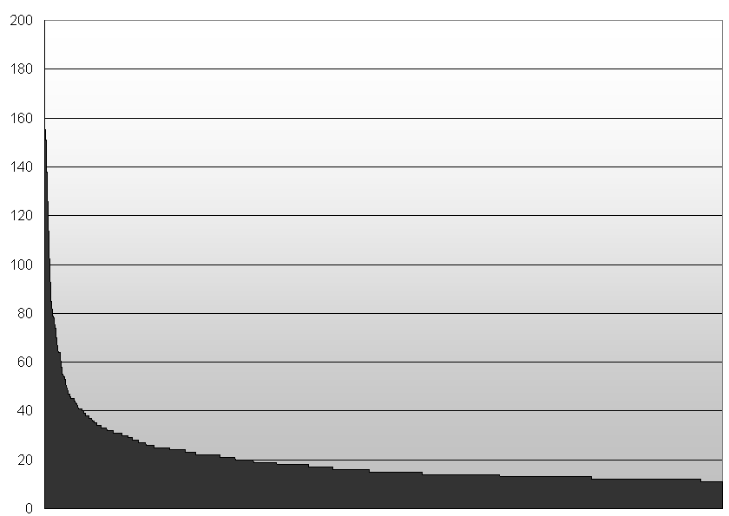

Figure 1: Distribution of the of 3000 most
common shingles in a standard article set

3.2. Detailed analysis of candidates

Detailed analysis is primary performed using fuzzy sentence analysis based on the double Levensthein metric [12]. Given two candidate sentences, operations are defined which can be used to transform one sentence into the other. Such operations include inserting, updating and removing, and are applied both on a word and on a character level. A cost model is specified, which assigns a cost value to each operation.

Total transformation cost can then be computed for every pair of sentences. Because resulting values cannot easily be normalized, a global set of rules has been defined based on experiments with sample data, which determines cost requirements qualifying two sentences as plagiarism candidates. Customizable profiles of cost models allow for adaptions of the algorithm to domain-specific peculiarities, for example differences in writing style between sports and politics.

Fuzzy sentence analysis has yielded very good results for highly similar articles. Article mutations, slightly altered versions of the same article published in different newspaper editions, were used as benchmarks and have been identified by the algorithm with high reliability. However, in diffusion analysis, where emphasis is on detection of reuse of phrases and formulations as components of sentences, results were less than optimal due to the order dependence of the method used. Consequentially, an order-independent method for detailed analysis of similarity has been researched and implemented: Word group analysis applies the principles of the double Levensthein metric to groups of words in articles, disregarding group order. Typical group size ranges from three to five, with experiments showing that for the German test corpus used groups of three deliver good results. While quantification of enhancements achieved over fuzzy sentence analysis is subject to further experiments, preliminary tests show that word group analysis catches many phrase reuses otherwise ignored.
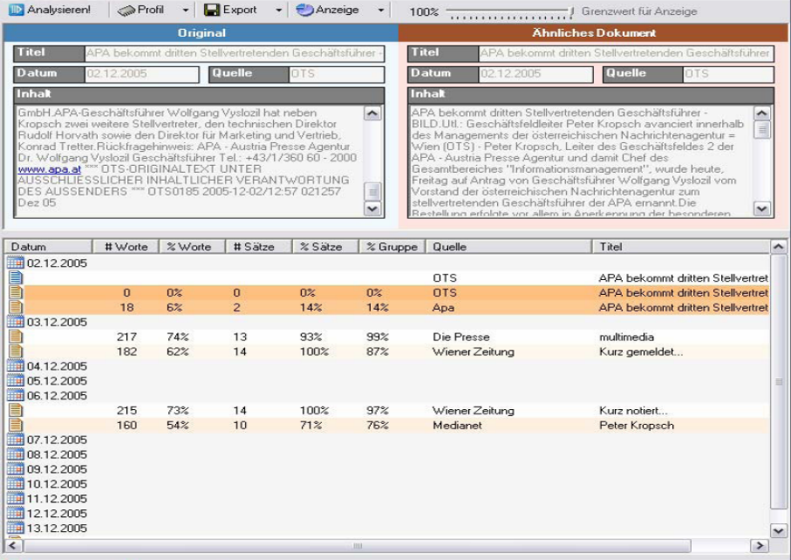

Figure 2: User Interface for detailed
analysis of identified plagiarisms

4. User Interface

Articles identified by detailed analysis as potential plagiarisms are presented to users in a visual interface for further manual analysis. For an original article of interest, a list of candidate plagiarisms is displayed sorted by date of article release, starting with the most recent entries found. For each candidate, the list shows statistical information as provided by the detailed analysis, in comparison to the original article. Title and source media are displayed as reference for each article, too. Users can immediately identify the number of equal words and sentences qualifying an article as a candidate plagiarism in the appropriate list columns. To further enhance perception of similarity, lines in the list are color coded, with brighter shades of orange denoting articles more similar to the original document. Figure 2 depicts the user interface, the 3rd and 4th line of the list have bright colors in the actual dialog window. Candidate lists may grow to several hundred entries if an original article is very general in content, or covers a topic for which many articles are available. To allow identification of similarities in such a case, an interactive slider has been implemented, which determines a minimum level of similarity below which candidate articles are hidden from view. Using this slider, users can quickly reduce large amounts of candidates to relevant subsets.

Once a manual selection of candidates has been made, each candidate can directly be compared to the original article in textual form. The two articles are presented next to each other, with differences as determined by the Levensthein metric for sentences or words being color-coded within article text. For example, an identical word group found in both articles would be highlighted, with the highlight growing brighter with the distance of group occurrence in both articles being closer. Similar encodings are used to denote additions and removals of words. Navigating one of the textual displays synchronizes the other, ensuring that relevant text are always visible. Identified and verified plagiarisms can be exported to a variety of formats, a step that concludes the analysis.

5. Results

While quantitative experiments are still in progress, preliminary results have been obtained from applying the algorithms described in this publication to real-world datasets provided by APA and letting domain experts decide on the quality of found results. By comparing candidate plagiarisms to mutations of articles, it could be established that plagiarisms consisting of slightly modified original articles are identified with a high degree of reliability. Characteristical slogans or statements were identified reliably, too, but accompanied with a large number of false positives, which users manually had to filter out. Result characteristics, for example distribution of direct reuses of formulations across sources, generally matched past experiences of domain experts.

6. Future Work

Most future work will be targeted at quantitative evaluation of the methodology and system described. Sample datasets will be defined for date ranges for which diffusion of certain statements or slogans is approximately known from manual analysis. Precision and recall analysis will then be done against these benchmarks. Adaptions to the cost models used in fuzzy sentence analysis are envisioned to improve performance by including domain-specific knowledge. Extension and adaption of the methodology is envisioned into the direction of language independence. Most algorithms used are per definition independent of language, however, this does not guarantee invariance of results in regard to language. Consequentially, the methodology will be evaluated with English news article in parallel to the German data set currently in use.

7. Concluding Remarks

In this publication, we have presented a methodology and implementation for identifying plagiarisms and analyzing diffusion of textual content in press agency news articles. Experiments have shown that plagiarisms can be detected in very large sets of articles, and that found results are of high practical relevance for press agencies. We are confident that by integrating the methods described in this publication into their daily workflow, press agencies can identify a significant amount of plagiarisms and take according action to protect their rights.

8. Acknowledgements

The Know-Center is a Competence Center funded within the Austrian Competence Centers Programme KPlus under the auspices of the Austrian Ministry of Transport, Innovation and Technology (www.kplus.at).

We would like to thank to thank Clemens Pig and Heinz Tschigg of APA MediaWatch, and Waltraud Wiedermann of the Austrian Press Agency, for their feedback and efforts.

9. References

[1] Wikipedia Online Encyclopaedia, “Plagiarism” http://www.wikipedia.org, Internet, 2006
[2] Context GmbH, “Plagiarism Finder”, http://www.context-gmbh.de, Internet, 2006
[3] IParadigms LLC, “TurnItIn”, http://www.turnitin.com, Internet, 2006
[4] N.Gibbs, J.Morse, C.B.Thomas, V.Novak, “Reading between the lines”, Summarizing the scandal surrounding the New York Times reporter Jayson Blair, Time Magazine, USA, 2003
[5] Austria Presse Agentur, Vienna, Austria, http://www.apa.at, Internet, 2006
[6] MediaWatch, Innsbruck, Austria, http://www.apa-mediawatch.at, Internet, 2006
[7] W.Kienreich, V.Sabol, M.Granitzer, W.Klieber, M.Lux, W.Sarka, "A Visual Query Interface for a Very Large Newspaper Article Repository", Proceedings of TAKMA 2005 - Sixth International Workshop on Theory and Applications of Knowledge Management, Kopenhagen, Denmark, 2005
[8] E.Goffman, “Frame Analysis: An Essay on the Organization of Experience”, Harper and Row, London, UK, 1974
[9] G. Cao, D. Song, P.D. Bruza, “Suffix Tree Clustering on Post-retrieval Documents”, DSTC Technical Report, Distributed Systems Technology Centre, Australia, 2003
[10] A.Z. Broder, S.C. Glassman, M.S. Manasse, G. Zweig, “Syntactic clustering of the Web”, Selected papers from the sixth international conference on World Wide Web, Elsevier Science, Publishers Ltd., Essex, UK, 1997
[11] D. Dhyani, W. K.NG, S.S. Bhomwick, “A Survey of Web Metrics”, ACM Computing Surveys, Vol. 34, No. 4, December 2002, pp. 469–503.
[12] R.O.Duda, P.E.Hart, D.G.Stork, “Pattern Classification”, Wiley-Interscience, 2001.

